Multiple choice section

Question 1 [7.1]

The number missing from the equation 8 × 5 = 36 + __ is:

A 4 B 16 C 40 D 45

Question 2 [7.3]

The expression missing from the box below is:

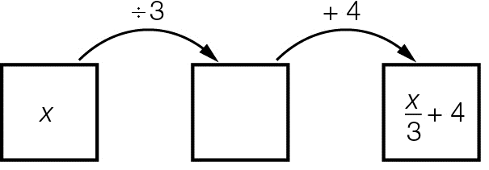

A x + 3 B 3x C  D 4x

Question 3 [7.4]

To balance the equation, the expression  must equal:

A 3 B 4 C 12 D 9

Question 4 [7.2]

Two times a number plus six is equal to twenty four is written as:

A 2n + 6 = 24 B 2 + n + 6 = 24 C  + 6 = 24 D 2n – 6 = 24

Question 5 [7.1]

The underlined number is incorrect in the equation 5 + 4 = 8. The number should be:

A 3 B 4 C 5 D 6

Question 6 [7.4]

 is equivalent to:

A  B  C  D 

Question 7 [7.3]

Using backtracking, the first step to solve  + 7 = 9 is to:

A multiply both sides by 3 B add 7 to both sides

C divide both sides by 3 D subtract 7 from both sides

Question 8 [7.4]

The equation 6x – 3 = 15 has the solution:

A x = 1 B x = 2 C x = 3 D x = 4

Question 9 [7.2]

If x = 7 is substituted into , the result is:

A 30 B 8 C 45 D 15

Question 10 [7.5]

If two pencils cost $1 and two notebooks cost $5, what is the cost of one pencil and one notebook?

A $1 B $2 C $3 D $4

Multiple-choice total marks: ____ / 10

Short answer section

Question 11 3 marks [7.1, 7.2, 7.3]

variable multiplication subtraction equation solution equivalent

(a) The inverse operation of subtraction is _______________.

(b) 10 + 3 = 13 is an _______________.

(c) A _________________ describes an unknown value ().

Question 12 3 marks [7.1]

For each of the following number sentences, check if left-hand side (LHS) is equal to the right-hand side (RHS). Select True or False for each number sentence.

|  |  |  |  |  |  |
| --- | --- | --- | --- | --- | --- |
|  | LHS |  | RHS | True | False |
| (a) | 4 + 3 × 8 | = | 56 |  |  |
| (b) | 30 – 7 | = | 4 + 19 |  |  |
| (c) | 5 × 5 | = |  |  |  |

Question 13 2 marks [7.1]

Write each as a number sentence using numbers and mathematical symbols only.

(a) Twenty added to fifteen is equal to thirty-five.

(b) Forty divided by five is equal to four multiplied by two.

Question 14 1 mark [7.1]

Sally is 17 cm taller than Jessie. If Jessie is 120 cm tall, write a number sentence to find Sally’s height.

__________ + __________=__________

Question 15 3 marks [7.2]

Write each of the following equations in words.

(a) 9 + y = 13 _____________________________________________________________________

(b) _______________________________________________________________________

(c) _____________________________________________________________________

Question 16 2 marks [7.2]

For the following equations, does the value in brackets make the equation true? Circle Yes or No.

(a) b + 8 = 12 (b = 4) Yes or No

(b)  (x = 12) Yes or No

Question 17 4 marks [7.2]

Find the solution by using the guess, check and improve method.

(a) 

(b) 

Question 18 3 marks [7.3]

A number is doubled then six added to the result to give an answer of twenty-eight. Write an equation and then solve using backtracking. Use n to represent the unknown number.

Question 19 2 marks [7.3]

Write the missing operations (+, –, × or ÷) needed to complete each of the following flowcharts.

(a) ______ ______

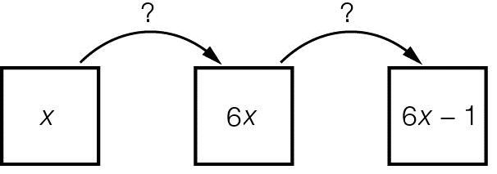

(b) ______ ______

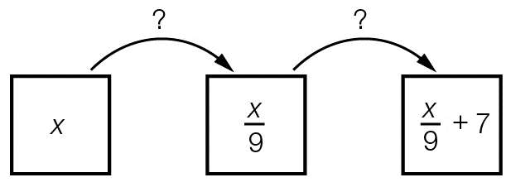

Question 20 2 marks [7.3]

The following flowchart represents an equation.

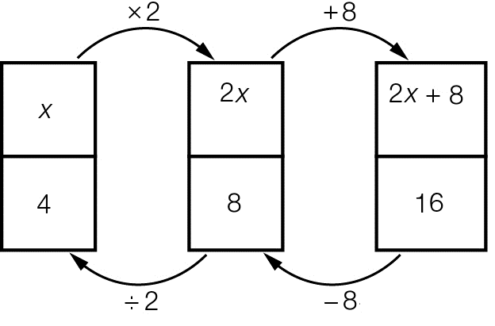

(a) What is the equation to be solved? __________ + __________ = __________

(b) What is the solution to the equation? _________

Question 21 4 marks [7.3]

Use backtracking to solve each of the following equations.

(a) 

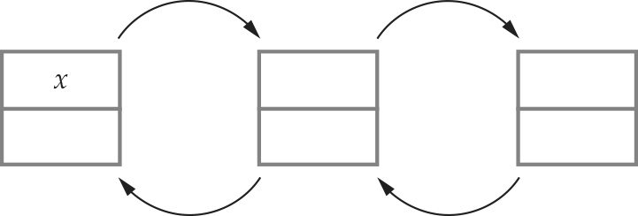

(b) 



Question 22 2 marks [7.4]

This set of scales is balanced. The left-hand side has 7 apples and 1 pineapple and the right-hand side  
has 2 pineapples and 3 apples.

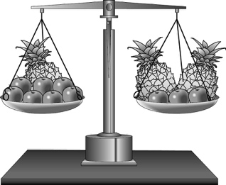

(a) If three apples are taken from the right hand side, the scales become unbalanced. Which side is now heavier?

(b) How can the scales be balanced without putting the apples back onto the scales?

Question 23 4 marks [7.4]

Solve each of the following equations using the balance method.

(a) 3x + 6 = 21

(b) 

Short answer total:________/35

Extended answer section

Question 24 4 marks [7.5]

Andrea has $385 to spend on three shirts. After buying them, she still had $25 left over. Each shirt cost the same amount.

(a) Write an equation that shows this situation. Let s represent the cost of one shirt.

(b) How much did each shirt cost?

Question 25 4 marks [7.5]

Benny and Michael have $115 between them. Benny has four times as much as Michael.

(a) Let x represent the amount of money Michael has. Write an equation for this situation.

_______________ + _______________ = 115

(b) Solve the equation.

(c) Write the amount that each of them has.

Question 26 3 marks [7.5]

Aaron bought a drink and a sandwich for $11. The drink cost $3.70, what is the cost of the sandwich?  
If c represents the cost of the sandwich, form an equation and solve it to find the value of c.

Extended answer total:_________/11

TOTAL test marks: _______ / 56